EX 5 COMPARATIVE ANALYSIS OF VGG, RESNET, AND GOOGLENET
DATE:
Problem Statement:
Implement and compare the performance of three popular CNN architectures: VGG, ResNet, and GoogLeNet for image classification. Use a labeled dataset to train each model and evaluate their convergence and accuracy.
Suggested Dataset: Dogs vs. Cats dataset
Objectives:
- Understand the architectural differences between VGG, ResNet, and GoogLeNet.
- Train all three models on the same dataset using transfer learning.
- Analyze and compare performance using validation accuracy.
- Apply the trained models to predict classes for custom images.
Scope:
This experiment demonstrates the power of transfer learning using pre-trained CNN models. Students explore how architectural changes affect accuracy and generalization. Comparing models under identical training settings aids in choosing the right model for real-world applications.
Tools and Libraries Used:
- Python 3.x
- PyTorch
- torchvision
- Matplotlib
- PIL (Python Imaging Library)
Implementation Steps:
Step 1: Import Necessary Libraries
import torch import torch.nn as nn import torch.optim as optim
from torchvision import datasets, models, transforms from torch.utils.data import DataLoader, random_split, Subset import matplotlib.pyplot as plt from PIL import Image import os
Step 2: Configure Device and Define Labels
device = torch.device("cuda" if torch.cuda.is_available() else "cpu") print("Using device:", device)

class_names = ['airplane', 'automobile', 'bird', 'cat', 'deer', 'dog', 'frog', 'horse', 'ship', 'truck']

Step 3: Preprocess Data and Load CIFAR-10
transform = transforms.Compose([ transforms.Resize((224, 224)), transforms.ToTensor(),
transforms.Normalize((0.5, 0.5, 0.5), (0.5, 0.5, 0.5))
])

dataset = datasets.CIFAR10(root='./data', train=True, download=True, transform=transform)
test_dataset = datasets.CIFAR10(root='./data', train=False, download=True, transform=transform)

dataset = Subset(dataset, range(500)) train_size = int(0.8 * len(dataset)) val_size = len(dataset) - train_size
train_dataset, val_dataset = random_split(dataset, [train_size, val_size])

train_loader = DataLoader(train_dataset, batch_size=64, shuffle=True) val_loader = DataLoader(val_dataset, batch_size=64, shuffle=False)

Step 4: Define Training and Evaluation Function
def train_and_evaluate(model, name, num_epochs=5):
model = model.to(device) criterion = nn.CrossEntropyLoss()
optimizer = optim.Adam(model.parameters(), lr=1e-4)

train_accs, val_accs = [], []

for epoch in range(num_epochs): model.train() correct, total = 0, 0 for inputs, labels in train_loader: inputs, labels = inputs.to(device), labels.to(device)

optimizer.zero_grad() outputs = model(inputs) loss = criterion(outputs, labels) loss.backward() optimizer.step()
_, predicted = torch.max(outputs, 1) correct += (predicted == labels).sum().item() total += labels.size(0)
train_accs.append(100 * correct / total)

model.eval() correct, total = 0, 0 with torch.no_grad(): for inputs, labels in val_loader: inputs, labels = inputs.to(device), labels.to(device) outputs = model(inputs) _, predicted = outputs.max(1)
correct += (predicted == labels).sum().item() total += labels.size(0)
val_accs.append(100 * correct / total)

print(f"{name} Epoch {epoch+1}/{num_epochs} - Train Acc: {train_accs[-1]:.2f}%, Val Acc: {val_accs[-1]:.2f}%")

return model, train_accs, val_accs

Step 5: Select Pretrained Models and Replace Final Layers
def get_model(name): if name == "vgg": model = models.vgg16(pretrained=True) model.classifier[6] = nn.Linear(4096, 10) elif name == "resnet": model = models.resnet18(pretrained=True) model.fc = nn.Linear(model.fc.in_features, 10) elif name == "googlenet":
model = models.googlenet(pretrained=True, aux_logits=True) model.fc = nn.Linear(model.fc.in_features, 10) else:
raise ValueError("Unknown model") return model

Step 6: Train All Models and Collect Results

results = {} trained_models = {}

for model_name in ["vgg", "resnet", "googlenet"]:
print(f"\n🔹 Training {model_name.upper()} on CIFAR-10...")
model = get_model(model_name)
trained_model, train_acc, val_acc = train_and_evaluate(model, model_name.upper(), num_epochs=5)
results[model_name] = (train_acc, val_acc) trained_models[model_name] = trained_model Step 7: Plot Accuracy Comparison

plt.figure(figsize=(10, 6)) for name, (train_acc, val_acc) in results.items(): plt.plot(val_acc, label=f'{name.upper()} Val Acc') plt.title('Validation Accuracy Comparison on CIFAR-10') plt.xlabel('Epoch') plt.ylabel('Accuracy (%)') plt.legend() plt.grid(True)
plt.show()

Step 8: Predict on Custom Image

def predict_image(image_path, models_dict):
image = Image.open(image_path).convert('RGB') image = transform(image).unsqueeze(0).to(device)

print(f"\n🖼 Prediction results for image: {image_path}") for model_name, model in models_dict.items(): model.eval() with torch.no_grad():
outputs = model(image) _, predicted = outputs.max(1)
pred_class = class_names[predicted.item()]
print(f"{model_name.upper():<10} => {pred_class}")

custom_image_path = "download.jpeg" if os.path.exists(custom_image_path): predict_image(custom_image_path, trained_models) else:
print(f"\n❗ Image not found: {custom_image_path}. Please add an image to test.")

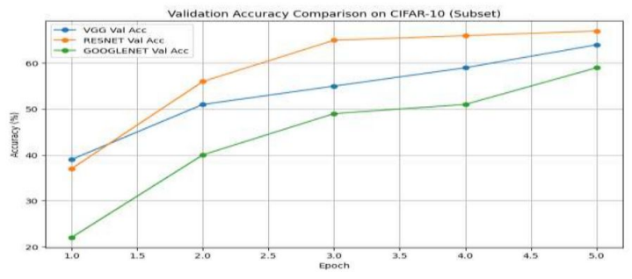

Conclusion:
This experiment successfully compares three state-of-the-art CNN architectures—VGG16, ResNet18, and GoogLeNet—on an image classification task. The experiment demonstrates how model depth, skip connections (ResNet), and inception modules (GoogLeNet) influence learning capability and accuracy. Such comparisons guide model selection for future deployment tasks.

